**Steps to run Employee Portal**

Step 1: copy the zip file into any location and extract it.

Step 2: open command prompt and navigate to Employee portal folder

Step 3: run **npm install** command.

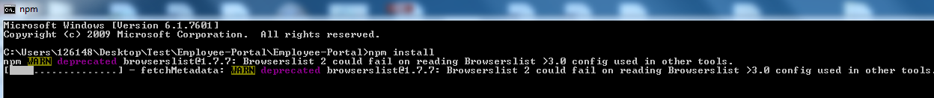

Step 4: run **npm start** command

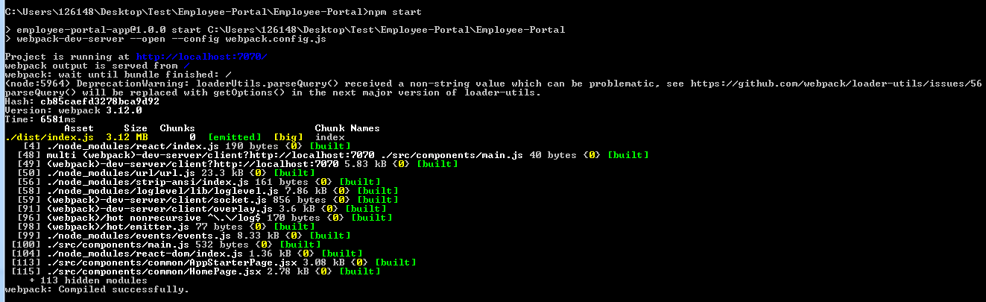

Step 5: Access the application using below url.

<http://localhost:7070>

**Mandatory Notes:**

1. Since this application developed using node and react, we have to install node and react.
2. I have configured default username and password. Use below user name and password

**Username: venki**

**Password: venki**

1. Since This application uses CDN notations for high charts , we have to make sure internet is available to access this application